**CSS Selectors [Definition and Description]**

CSS selectors are being used to specify, to locate, or to choose the HTML elements for their own style or declaration. A selector can be a series of simple selectors separated by combinators. An element match with a selector is called a *subject* of the selector.

**CSS Selector Syntax:**

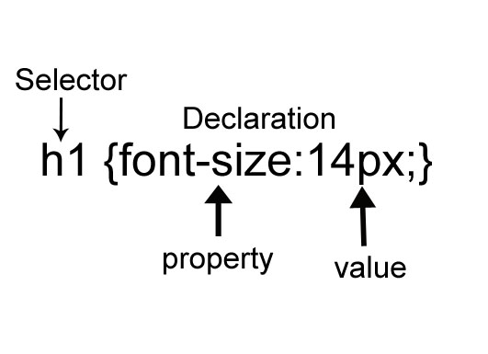

**Simple selectors**

|  |  |  |  |
| --- | --- | --- | --- |
| Pattern | Examples | Description | Meaning |
| * | * | Universal Selector | Select all elements. |
| *elementname* | h1 | Type Selector | Select element with matching node name. |
| .*classname* | .content | Class Selector | Select element s that given a class attribute. |
| *#idname* | #content | ID Selector | Select element that has a specified id attribute.  One element must have a unique id. |
| *[attribute]* | [autoplay] | Attribute selector | Select all element with a autoplay attribute. |
| *[attribute=value]* | [target=_blank] | Selects all elements with target=_blank |
| *[attribute~=value]* | [title~=beauty] | Selects all elements with a title attribute containing the word “beauty” |
| *[attribute|=value]* | [name|en] | Selects all elements with a name attribute value starting with “en” |
| *[attribute^=value]* | p[title^=”home”] | Selects every <p> element whose title attribute value begins with “home” |
| *[attribute$=value]* | img[src$=”.jpg”] | Selects every <img> element whose src attribute value end with “.jpg” |
| *[attribute*=value]* | form[name*=”menu”] | Selects every <form> element whose name attribute value contains the substring “menu” |

**Combinators** are used to have a chain of selectors. It separates the simple selectors to other selectors to select the proper subject of the selector.

Combinators:

|  |  |  |  |
| --- | --- | --- | --- |
| Pattern | Examples | Description | Meaning |
| element+element | div + p | Adjacent Sibling Combinator | Selects all <p> elements where the parent is a <div> element |
| element~element | p ~ ul | General Sibling Combinator | Selects every <ul> element aheaded by a <p> element |
| element>element | ul > li | Child combinator | Selects all <li> element where the parent is <ul> element |
| element element | ol li | Descendant combinator | Selects all <li> element inside <ol> element |

**Groups of Selectors**

When there are many selectors that share the same declarations, it will be grouped into a comma-separated list.

h1,h2,h3{

color:black;

text-decoration:underline;

}

Example:

Pattern: *element,element*